1. A carefully formulated scientific explanation that is based on extensive observations and is in
accord with scientific principles is called a
A) hypothesis.
B) theory.
C) fact.
D) control.
E) postulate.

2. Sweating is a useful cooling mechanism for humans because water
A) takes up a great deal of heat in changing from its liquid state to its gaseous state.
B) takes up a great deal of heat in changing from its solid state to its liquid state.
C) can exist in two states at temperatures common on Earth.
D) is an outstanding solvent.
E) ionizes readily.

3. Hydrophilic molecules
A) form hydrogen bonds among themselves.
B) are neutral and nonpolar.
C) readily dissolve in water.
D) do not readily dissolve in water.
E) are repelled by water.

4. Which of the following is an example of hydrogen bonding?
A) The bond between O and H in a single molecule of water
B) The bond between O of one water molecule and H of a second water molecule
C) The bond between O of one water molecule and O of a second water molecule
D) The bond between H of one water molecule and H of a second water molecule
E) The bond between the H of a water molecule and H of a hydrogen molecule

5. Sodium (Na), atomic number 11, has a tendency to lose an electron in the presence of chlorine.
After losing the electron, Na has ________ protons in its nucleus.
A) 10 B) 11 C) 12 D) 21 E) 22

6. Phosphorus has an atomic number of 15, so what is the distribution of its electrons?

7. If you examined the human body, which of the following combinations of elements would be
most common?
A) C, O, P, S
B) C, Na, O, N
C) Cl, Ca, C, H
D) C, S, Ca, N
E) O, N, H, C

8. A basic difference between a prokaryotic cell and a eukaryotic cell is that the prokaryotic cell
A) possesses membrane- bound organelles.
B) lacks DNA.
C) lacks a nucleus.
D) is considerably larger.
E) is structurally more complex

9. The carbohydrate in DNA is
A) ribose.
B) cellulose.
C) glucose.
D) deoxyribose.
E) phosphate.

10. The "backbone" of a nucleic acid molecule is made of
A) nitrogenous bases.
B) sugar and phosphate groups.
C) ATP molecules.
D) NAD+ and FAD.
E) amino acids.

11. Which of the following may possess primary, secondary, tertiary, and quaternary structures?
A) Proteins B) Carbohydrates
C) Lipids D) Nucleic acids

12. In a biological membrane, the phospholipids are arranged with the fatty acid chains facing the
interior of the membrane. As a result, the interior of the membrane is
A) hydrophobic.
B) hydrophilic.
C) charged.
D) polar.
E) filled with water.

13. In eukaryotic cells, what name is given to the region between the nucleus and the plasma
membrane?
A) cytoplasm B) phospholipid bilayer
C) nucleoid D) chloroplast

14. Lysosomes are responsible for ______.
A) lipid synthesis B) cellular respiration
C) digestion and recycling D) protein synthesis

15. Which organelle is responsible for photosynthesis?
A) smooth endoplasmic reticulum B) mitochondrion
C) ribosome D) chloroplast

16. During cell reproduction (cell division), chromatin fibers coil up into structures called
A) ribosomes.
B) lysosomes.
C) peroxisomes.
D) chromosomes.
E) nucleoli.

17. A cell that neither gains nor loses water when it is immersed in a solution is
A) isotonic to its environment.
B) hypertonic to its environment.
C) hypotonic to its environment.
D) metabolically inactive.
E) dead.

18. In a hypotonic solution, an animal cell will
A) lyse (burst)
B) experience turgor.
C) neither gain nor lose water.
D) shrivel.
E) lose water.

19. A plant cell in a hypotonic solution
A) is turgid.
B) lyses.
C) shrivels.
D) wilts.
E) is flaccid.

20. Which of the following statements regarding the Golgi apparatus is false ?
A) The Golgi apparatus receives fromthe cis face, but ships from the trans face
B) The Golgi apparatus modifies products from the ER
C) The Golgi apparatus decreases in size when a cell increases its protein production.
D) The Golgi apparatus sorts and packages
E) The Golgi apparatus ships and receives

21. Smooth endoplasmic reticulum
A) stores calcium ions in muscle cells.
B) Metabolizes carbohydrates
C) Sy;nthesizes lipids
D) Detoxifies poisons
E) All of the above

22. What kinds of molecules pass through a cell membrane most easily (move by simple diffusion)?
A) large and hydrophobic
B) small and hydrophobic
C) large polar
D) ionic
E) monosaccharides such as glucose

23. An atom's nucleus contains
A) neutrons
B) protons
C) electrons
D) protons and neutrons
E) neutrons and electrons

24. The element lithium has 3 protons and 4 neutrons in its nucleus. Its mass number is
A) 1
B) 3
C) 7
D) 12
E) 13

24. The element lithium has 3 protons and 4 neutrons in its nucleus. It contains how many electrons
A) 1
B) 3
C) 7
D) 12
E) 13

25. 26 and 27. Carbon has an atomic number of 6
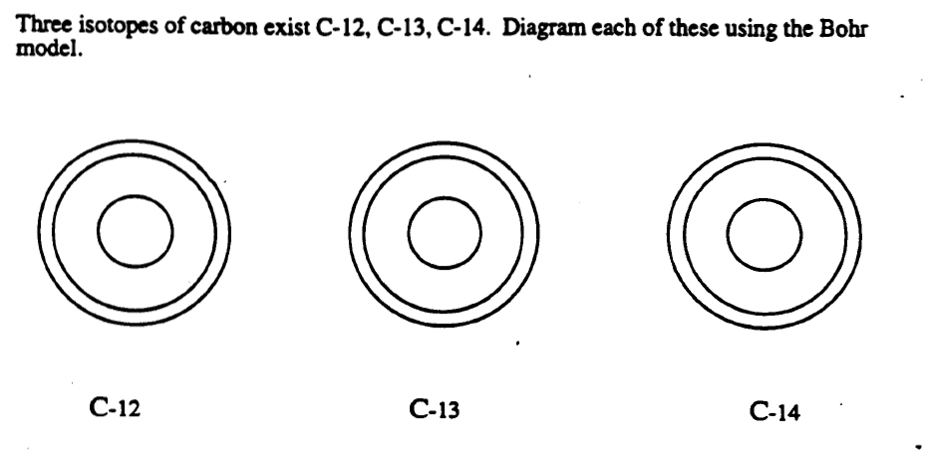

28. Covalent bonds occur when
A) electrons are shared between atoms
B) electrons are transferred between atoms
C) electrons are lost
D) electrons are gained
E) opposite charges attract atoms together

29 and 30. What type of bonds does water contain? Draw a Hydrogen bond between the following water molecules.

